Chain Rule

Question 1.
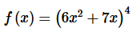
Question 2.
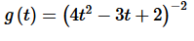
Question 3.
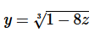
Question 4.
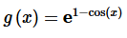
Question 5.
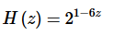
Question 6.
